Final Exam: BA-311 Fall 2020 Name:
INSTRUCTIONS
Read each question carefully. Answer each question completely. Blank responses are worth 0 points. Intelligent/partial responses are usually worth more than zero points...so don’t skip anything. Please follow the instructions carefully: if I ask for one and you give me two, I am going to grade the first one. Good luck!

- Consider the company Gerber Gear and the following example. The company recently launched its new product line – Armbar. The Armbar fits in pocket like a folder knife and operates like a fully capable multitool. It comes in 2 models and 3 colors. Retailers are expected to sell this product for $39.99/each, but Gerber Gear gives retailers an introductory discount which leads them to sell the product for $25/each for a limited time. Which ONE pricing strategy does this company seem to be using in the example? Explain and justify your answer.

- What is the current level of distribution intensity for Gerber Gear’s Magniplier product? Explain and justify your answer.

- Name 2 retailers that sell Gerber Gear products (not including Gerber Gear). Identify the type of retailer explain why each of these retail partnerships makes sense.

- Consider the following integrated marketing communication from Gerber Gear. Identify the goal from the AIDA model that this communication is attempting to accomplish. Explain your answer.
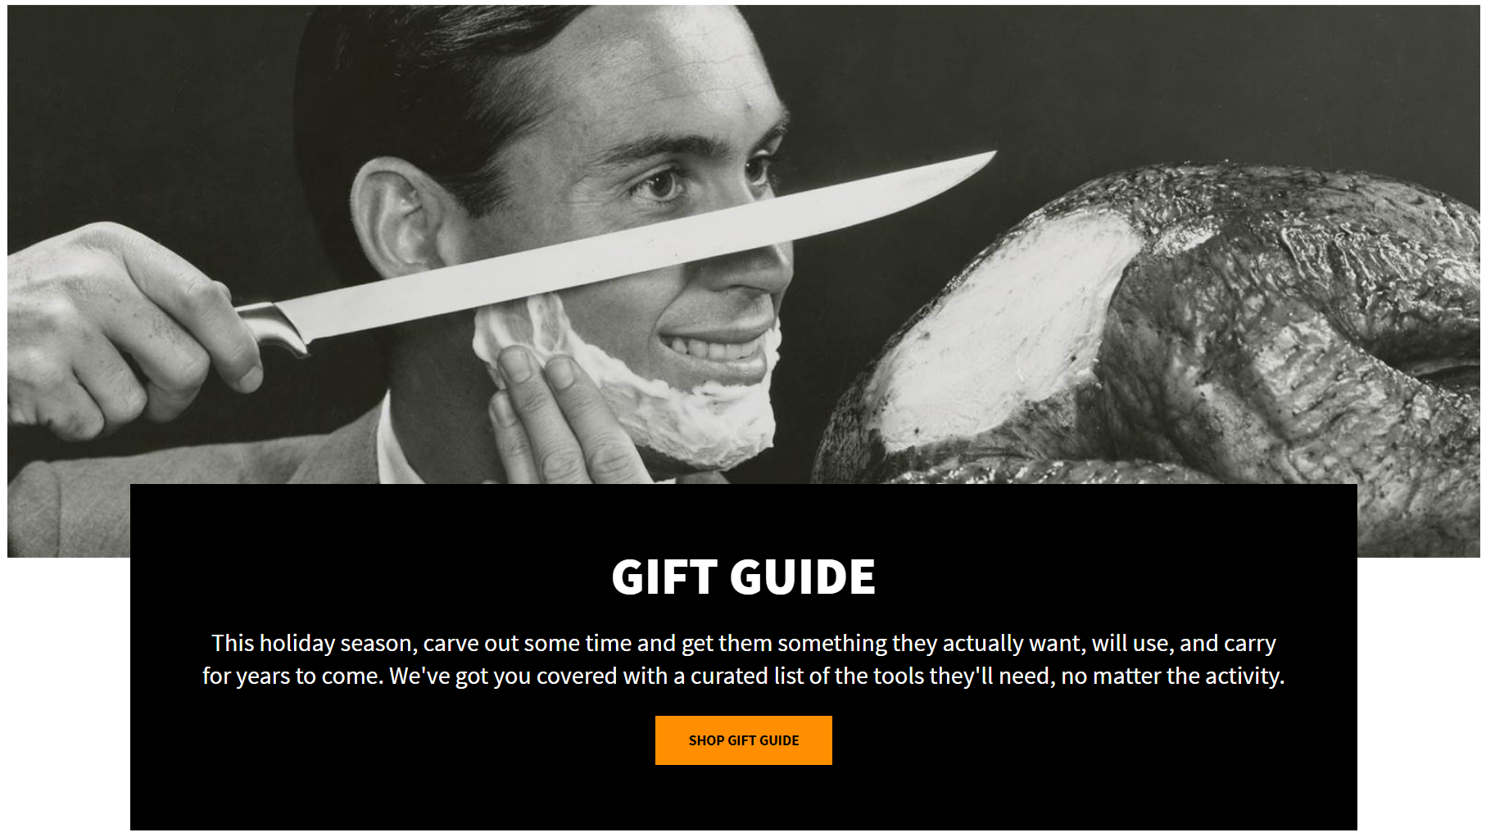

- Consider the following paid advertisement from Gerber Gear. Identify whether it is informative, persuasive, or reminder advertising. Explain your answer.

- Consider the following Social Media post from Gerber Gear. Which one of the 4e Social Media Framework steps is this example most addressing? Explain your answer.

FORMAT GUIDELINES
Make it easy for me to know which question you’re answering. All assignments should be submitted as Microsoft Office compatible documents. Use double-spacing and a size 12 font with one-inch margins. Don’t worry about page length or word count...focus on the assignment deliverables, course concepts, relevant research, and supporting materials.
All sourced content should be properly cited. This includes inline citation and a works cited section. Use MLA format please.

GRADING GUIDELINES
I am typically asking you to apply one or more specific course concepts (usually underlined in the question). Make sure you understand what I’m asking for. Attempting to apply the wrong course concept will typically results in a zero score.
A: You can earn 100% credit for correctly applying the appropriate course concept(s) in your answer and demonstrating your understanding of the concepts by connecting your answer to appropriate research and/or the specific product/company/scenario in question.
B: You can earn 80% credit for correctly applying the appropriate course concept(s) in your answer.
D: You can earn 60% credit for applying the appropriate course concept(s) in your answer.
F: You earn 0% credit for failing to apply the correct course concept or failing to answer the question at all.
GRADING RUBRIC
Deliverable |  | F | D | B | A
Question 1-6 (1 point each) |  | 0 | .60 | .80 | 1
Total |  | 0 | 3.6 | 4.8 | 6

LATE POLICY
I will accept late submissions for the midterm up to 24 hours past the original due date (not to exceed the final due date of the term). All late submissions are subject to 15% penalty of the total possible points. For example, a late submission worth up to 10 points may incur a 15% (1.5 point) penalty.

