Solar System Lab Instructions

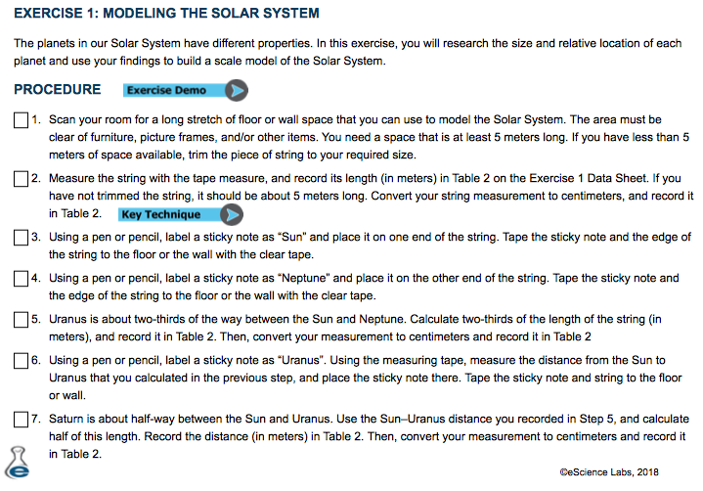

CONTINUE TO NEXT PAGE

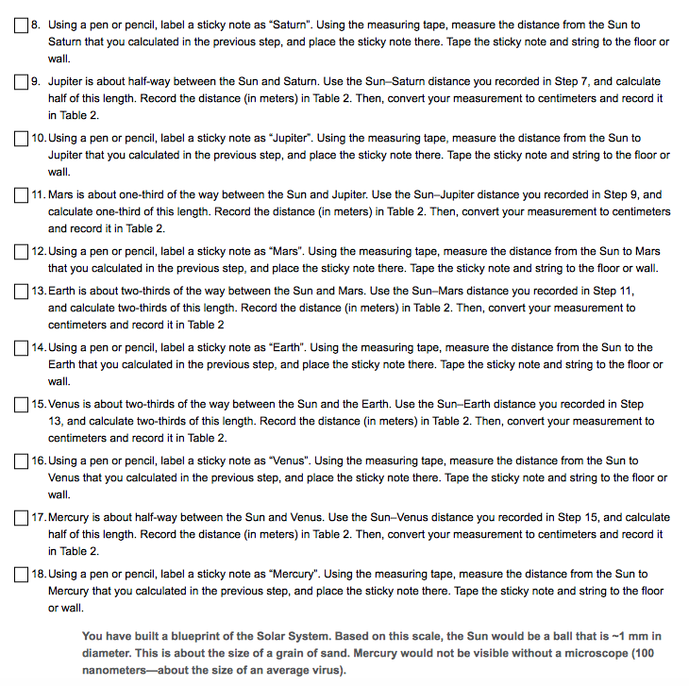CONTINUE TO NEXT PAGE

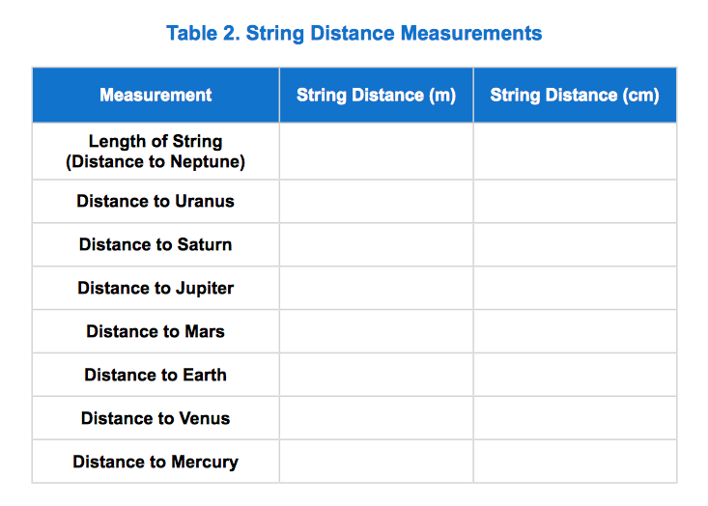

SUBMIT:
(1) TABLE 2
(2) PHOTO OF YOUR SOLAR SYSTEM

